7.**Experiments based on Tuples,Sets and its operation**

**Ex. No. : 7.1 Date:02/06/2024**

**Register No.: 231801047 Name: HANNAH JAMES**

The **DNA sequence** is composed of a series of nucleotides abbreviated as 'A', 'C', 'G', and 'T'.

* For example, "ACGAATTCCG" is a **DNA sequence**.

When studying **DNA**, it is useful to identify repeated sequences within the DNA.

Given a string s that represents a **DNA sequence**, return all the **10-letter-long** sequences (substrings) that occur more than once in a DNA molecule. You may return the answer in **any order**.

**Example 1:**

**Input:** s = "AAAAACCCCCAAAAACCCCCCAAAAAGGGTTT"

**Output:** ["AAAAACCCCC","CCCCCAAAAA"]

**Example 2:**

**Input:** s = "AAAAAAAAAAAAA"

**Output:** ["AAAAAAAAAA"]

**For example:**

| **Input** | **Result** |
| --- | --- |
| AAAAACCCCCAAAAACCCCCCAAAAAGGGTTT | AAAAACCCCC  CCCCCAAAAA |

**PROGRAM:**

def findRS (s):

sequences = {}

r = []

for i in range(len(s) - 9):

seq = s[i:i+10]

sequences[seq] = sequences.get(seq, 0) + 1

if sequences[seq] == 2:

r.append(seq)

return r

s1 = input()

for i in findRS (s1):

print(i)

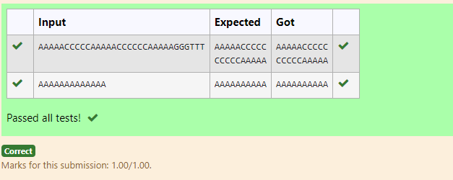

**Ex. No. : 7.2 Date: 02/06/2024**

**Register No.: 231801047 Name: HANNAH JAMES**

Given a tuple and a positive integer k, the task is to find the count of distinct pairs in the tuple whose sum is equal to **K**.

**Examples:**

**Input:** t = (5, 6, 5, 7, 7, 8 ), K = 13   
**Output:** 2   
**Explanation:**   
Pairs with sum K( = 13) are  {(5, 8), (6, 7), (6, 7)}.   
Therefore, distinct pairs with sum K( = 13) are { (5, 8), (6, 7) }.   
Therefore, the required output is 2.

**For example:**

| **Input** | **Result** |
| --- | --- |
| 1,2,1,2,5  3 | 1 |
| 1,2  0 | 0 |

**PROGRAM:**

t = input().split(',')

k = int(input())

s = []

s1=[]

for i in range(len(t)-1):

for j in range(i+1,len(t)):

if (int(t[i])+int(t[j]))==k and (t[i],t[j]) not in s1 and (t[i],t[j]) not in s1:

s1.append((t[i],t[j]))

s1.append((t[j],t[i]))

s.append((t[i],t[j]))

print(len(set(s)))

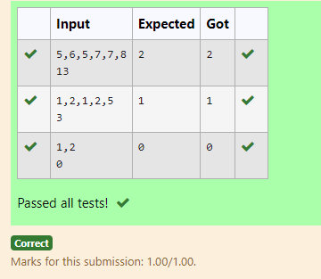

**Ex. No. : 7.3 Date: 02/06/2024**

**Register No.: 231801047 Name: HANNAH JAMES**

There is a malfunctioning keyboard where some letter keys do not work. All other keys on the keyboard work properly.

Given a string text of words separated by a single space (no leading or trailing spaces) and a string brokenLetters of all distinct letter keys that are broken, return the number of words in text you can fully type using this keyboard.

Example 1:

Input: text = "hello world", brokenLetters = "ad"

Output:

1

Explanation: We cannot type "world" because the 'd' key is broken.

**For example:**

| **Input** | **Result** |
| --- | --- |
| hello world  ad | 1 |
| Faculty Upskilling in Python Programming  ak | 2 |

**PROGRAM:**

t = input()

bLetters = input()

words = text.split()

c = 0

for word in words:

word=word.lower()

if any(letter in bLetters for letter in word):

continue

else:

c+= 1

print(c)

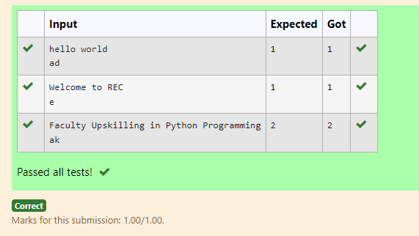

**Ex. No. : 7.4 Date: 02/06/2024**

**Register No.: 231801047 Name: HANNAH JAMES**

Write a program to eliminate the common elements in the given 2 arrays and print only the non-repeating

elements and the total number of such non-repeating elements.

Input Format:

The first line contains space-separated values, denoting the size of the two arrays in integer format respectively.

The next two lines contain the space-separated integer arrays to be compared.

[Sample](https://www.rajalakshmicolleges.net/moodle/mod/quiz/view.php?id=5127) Input:

5 4

1 2 8 6 5

2 6 8 10

[Sample](https://www.rajalakshmicolleges.net/moodle/mod/quiz/view.php?id=5127) Output:

1 5 10

3

[Sample](https://www.rajalakshmicolleges.net/moodle/mod/quiz/view.php?id=5127)  Input:

5 5

1 2 3 4 5

1 2 3 4 5

[Sample](https://www.rajalakshmicolleges.net/moodle/mod/quiz/view.php?id=5127) Output:

NO SUCH ELEMENTS

**For example:**

| **Input** | **Result** |
| --- | --- |
| 5 4  1 2 8 6 5  2 6 8 10 | 1 5 10  3 |

**PROGRAM:**

s1, s2 = map(int, input().split())

arr1 = list(map(int, input().split()))

arr2 = list(map(int, input().split()))

set1 = set(arr1)

set2 = set(arr2)

non_repeating = set1.symmetric_difference(set2)

print(*non_repeating)

print(len(non_repeating))

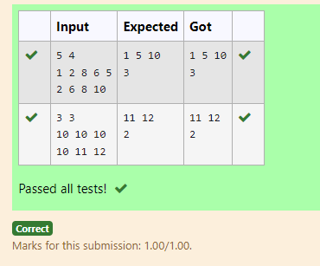

**Ex. No. : 7.5 Date: 02/06/2024**

**Register No.: 231801047 Name: HANNAH JAMES**

Given an array of integers nums containing n + 1 integers where each integer is in the range [1, n] inclusive.There is only **one repeated number** in nums, return *this repeated number*. Solve the problem using set.

**Example 1:**

**Input:** nums = [1,3,4,2,2]

**Output:** 2

**Example 2:**

**Input:** nums = [3,1,3,4,2]

**Output:** 3

**For example:**

| **Input** | **Result** |
| --- | --- |
| 1 3 4 4 2 | 4 |

**PROGRAM:**

n =input().split(" ")

n = list(n)

for i in range(len(n)):

for j in range(i+1,len(n)):

if n[i] == n[j]:

print(n[i])

exit(0)

